CREATING AN ADDITIONAL SUBTOTAL IN FINANCIAL STATEMENTS

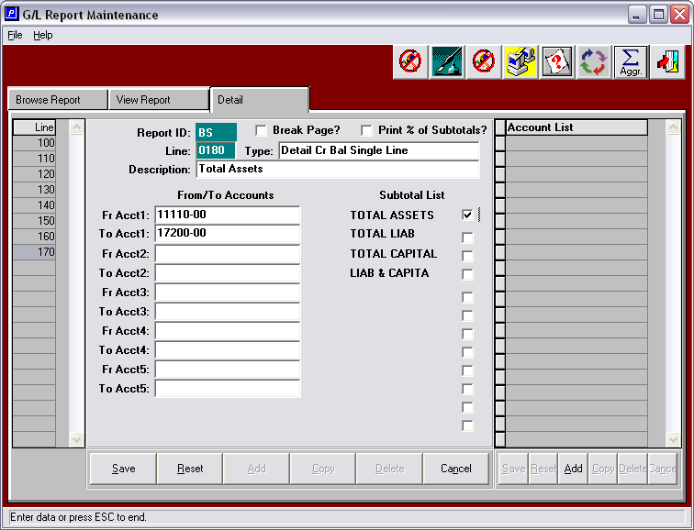
By using the Type: Detail Cr Bal Single Line or Detail Db Bal Single Line you can enter a range of accounts in the From/To Accounts section and they will total into one line. Enter the Description Field with your total description. You must also check off the subtotals in the subtotal list this range of accounts needs to be added into.

This option above is used if you need to add an additional subtotal not provided in the subtotal list on the screen.

